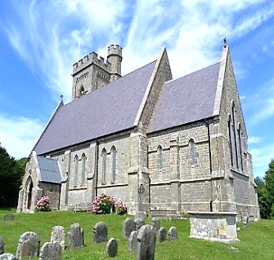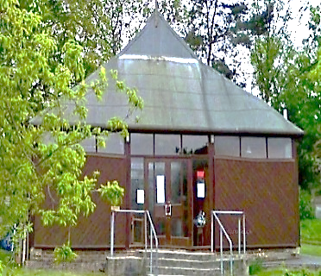

**Priest in Charge**: Revd. Sandi Wickens - 07395 106514

**AUGUST**

Sunday 25th 11.am Morning Praise

**SEPTEMBER**

**Sunday 1st** 11am **PET SERVICE**

Sunday 8th 11am Morning Praise

Sunday 15th 11am Holy Communion

Sunday 22nd 11am Morning Praise

**Sunday 29th** 11am

Holy Communion at St Laurence Church Guestling

**25th August & 1st September Newsletter**

[**www.fairlightchurches.org.uk**](http://www.fairlightchurches.org.uk)

**Please circulate to all those you think**

**might wish to come along**



**PET SERVICE**

Sunday 1st September at 11am is St Andrew’s yearly Pet Service, everyone is welcome. Our Pets are like our Family ~ so if you can bring your pet along ~ if you cannot make it in person, please email [paforfgw@gmail.com](mailto:paforfgw@gmail.com) attaching a photo if you have one and a few words about your beloved pet, or leave on the font in the church and they will be prayed for at the service.



Last Thursday of Family Fun is 29th August

at St Andrew’s

10am-12 Noon .



**Alone on Sundays?**  A number of us go home to an empty house on Sundays after church. It can be a lonely time.

If you would like to join with others in the same situation for a monthly Sunday lunch and some company in the afternoon, please tell Valerie Hornsby who will coordinate this.

Email: **valeriehornsby22@gmail.com**



**Friday 6th September**

**at 2.30pm**

Guest Speaker ~ Haydon Luke ~

**More History of Fairlight**

St Peter’s Church Fairlight

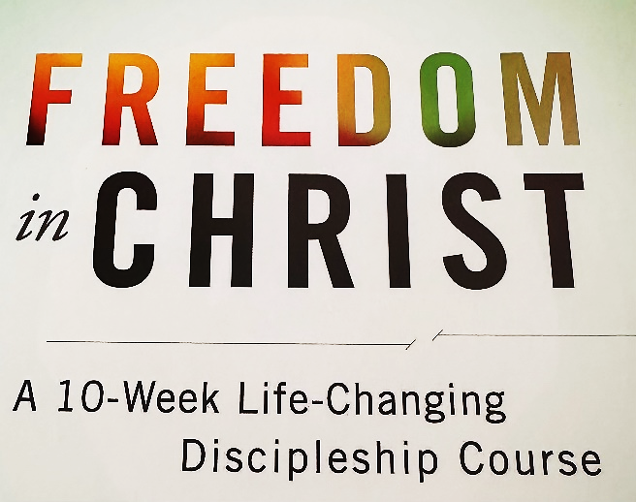**HOUSEGROUP**

Starting September 2nd to the end of November.    
The Fairlight Lodge house-group will be meeting at St Peter’s Church from September 2nd until the end of November at 10am-1pm on Monday mornings.  They will be studying a course called FREEDOM IN CHRIST. This is all about how we can become all that God intends us to be.  This course will help you to grasp the amazing truth of your identity in Christ, move on. Do come and join us.

**UPDATE** Chichester Cathedral will unveil special plans to mark two important anniversaries coming up next year. In 2025, Sussex will celebrate the Christian faith, marking the 950th anniversary of the Diocese of Chichester and Chichester Cathedral, as well as the 1700th anniversary of when the Nicene Creed first emerged.

2025 also marks the 1700th anniversary of the Council of Nicaea which resulted in the Nicene Creed emerging - a document still recited by Christians summarising the essence of what they believe.  A wide range of events celebrating both anniversaries are in the process of being organised. There is also a request from the cathedral asking our church communities to get involved in creating a journey through time - to capture the essence of the cathedral’s 950 years of Christian Faith. These special events will be on the newsletter in the coming weeks and months. **As a taster until more information is announced the celebrations under the banner of Chichester950 will include:**

* [***Religion, Revolution & Reformation*, 14th February – 15th November 2025**](https://www.chichestercathedral.org.uk/events/chichester950-religion-revolution-reformation)**:** An interactive exhibition sharing the story of the Christian faith in Sussex, revealed through people, events and objects, from 1075 to the present day;
* [***Together in Unity*, 17th May 2025:**](https://www.chichestercathedral.org.uk/events/chichester950-together-unity) A concert on the 60th anniversary of Leonard Bernstein’s *Chichester Psalms*, including the unveiling of a new musical composition;
* [***TrinityFest on the Green*, 15th June 2025**](https://www.chichestercathedral.org.uk/events/chichester950-trinityfest-green): Marking the Feast of the Holy Trinity, to which the Cathedral is dedicated, with a vibrant celebration uniting Chichester communities over food, music, and culture, on the Cathedral Green;
* [**Light Show**, **24th - 31st October 2025**](https://www.chichestercathedral.org.uk/events/chichester950-light-show): An immersive fine art, light and sound installation taking place over October Half Term, responding to the 950-year history of the Cathedral.

**Family Fun Day’s in August**

We need empty boxes for crafting/modelling. Please leave them in the

collection box at St Andrew’s. NO Toilet Roll tubes, but kitchen roll tubes are fine. We also need volunteers to help with setting up tables/chairs, crafts and refreshments. Let Jayne know if you’d like to get involved. [paforfgw@gmail.com](mailto:paforfgw@gmail.com)



DEMENTIA FRIENDLY SERVICE

at St Andrew’s Fairlight

At the PCC meeting last Monday, the possibility of holding a monthly Dementia Service was discussed. This would take place on either a Tuesday or Thursday afternoon. We need to set up a small team. If you would like to be part of the team, which would include providing refreshments and leading the service let Jayne know. [paforfgw@gmail.com](mailto:paforfgw@gmail.com)

Faith in Sussex Magazine Issue 37 - Summer 2024

<https://images.app.goo.gl/bbwkd9L1b8WDSs3D9>

To read the latest edition of Faith in Sussex click the link above

**There is still time to respond to This is our faith Questionnaire 2025** marks the 950th anniversary of the move of Christian mission in this diocese from Selsey to Chichester.  This gives us an opportunity to say something about who we are as the inheritors in the 21st century of this great momentum of Christian witness and faith. You are encouraged to respond to [four questions](https://gbr01.safelinks.protection.outlook.com/?url=https%3A%2F%2Fforms.office.com%2Fe%2FWwJpRseVkT&data=05%7C02%7CLisa.Williamson%40Chichester.Anglican.Org%7Cf3e16b973e69472c941d08dc8ae46f9b%7C46c16f751b724c0ca9eac6e2d6aa8b81%7C0%7C0%7C638537960956904883%7CUnknown%7CTWFpbGZsb3d8eyJWIjoiMC4wLjAwMDAiLCJQIjoiV2luMzIiLCJBTiI6Ik1haWwiLCJXVCI6Mn0%3D%7C0%7C%7C%7C&sdata=7zI0tMzwUALGBrOSxkdDUpogAA1WL%2BKLaJbBbNrh8%2FE%3D&reserved=0) about what your faith means to you, in whatever way you wish.  We would prefer succinct authenticity to a lengthy sermon!  The deadline for responses is **31st September 2024**. Too respond click on the four questions link above. There is an invitation to send us photographs that illustrate the diversity of our diocesan life and context.  Details about that are attached. (Emailed separately with this newsletter – please ensure you have permission if any image is of an identifiable person/s). This will be a record of what our Church is like today: we hope and pray that it will also encourage us to look to the future with hope and confidence in the abiding purposes of God’s plan for salvation and glory for his children.  *+ Martin Warner*

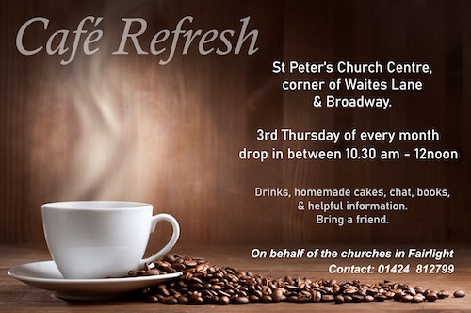

**2024**

19th SEPTEMBER

17th OCTOBER

21st NOVEMBER

19th DECEMBER

Parish Administrator Jayne Stevens – my working days 2.30pm-6pm on Tuesday, Wednesday and Friday and all-day Thursday 9am-5pm. If you need to contact me, 07539 652 000 - my email address is: paforfgw@gmail.com If at any time you would like to be removed from the mailing list in line with ‘GDPR’ let me know.

If you have a contribution for the newsletter, please contact me by midday on Thursday. Thank you, Jayne.

If you know anyone who might like to receive the newsletter, please ask them to email me. or contact me via the website: [www.fairlightchurches.org.uk](http://www.fairlightchurches.org.uk)

**I am now on holiday and will be back in the office on Tuesday 3rd September from 2.30pm**

**EVERYONE WELCOME**